Bellalago Academy
Collection Development Plan
2023
Written by Brenda Glover

Purpose Statement
The collection development plan acts a guideline to aid in selecting materials to serve the needs of students and curriculum. Additionally, the purpose of the plan is to foster a love of reading.
Background Statement
Bellalago Academy currently has over 8,100 items in the collection. It varies in reading levels and topics of interest. The collection spans from class sets of books, fiction, informational, and classroom resources.
Responsibility for Collection Development
The Osceola County School Board holds the final say in library material acquisition. The media specialist will work in collaboration with academic coaches, teachers, and students to identify current needs and develop the curriculum with approval from administration. Bellalago Academy serves students from PreK through eighth grade. Due to this, consideration is given to elementary and middle school students. Trends, age of materials, and circulation data will be utilized in acquiring new materials. As new programs are adopted and implemented the collection development policy will be changed.
Missions, Goals, and Objectives
Osceola County Mission: “Inspiring all learners to reach their highest potential as responsible, productive citizens.”
Osceola County School Librarians’ Association: “The Osceola County School Librarians’ Association supports literacy and curriculum through school media programs by promoting collaboration, emphasizing information literacy, technology skills cultivating the love of reading with students, colleagues and our community.”
Bellalago Academy School Mission: “Our mission at Bellalago Academy is to achieve life long learning by exploring education that is anchored in excellence.”
Objectives
The goal of the Bellalago Academy Media Center is to promote literacy through access to books that empower students with knowledge and life skills enabling them to reach their goals. In order to achieve this, the following will be used.
- Evaluate, provide, obtain, and promote information resources to meet the learning needs of all students
- Supplying information resources in various presentations
- Fostering an interest in reading
- Maintaining a culturally diverse collection
- Encouraging the use of the media center by students and faculty
- Collaborating with teachers to support the needs of their students
- Supporting the school’s curriculum and reading initiatives
Target Audience
Access to the media center is provided to students, teachers, and staff. There is a representation of diverse cultures and ethnic backgrounds. The population of Bellalago Academy is 1,159 students; 53% are Hispanic, 13% are LY, and 52% qualify for free lunch. Gifted, AVID, ESE, ESOL, and high school courses are offered.
Budgeting and Funding
Fundiing for the Bellalago Academy Media Center is provided by fundraisers. This is normally done by three for-profit Scholastic Book Fairs. The use of this money is to purchase books, furniture, supplies, incentives, book labeling, book repair, and other various materials needed. Additional fundraisers may be used throughout the school year.
Evaluation Criteria
All stake holders may put in a request for purchase at any time of the year. A stakeholder constitutes a faculty member, staff, student, or parent. If approved, items will be ordered as funding is available. All requests will be considered after consulting various selection aids as well as with the following questions:
- Is the item appropriate for students in grades K-8?
- Is the material/publish date relevant?
- Is it a reliable source?
- Does it support curriculum?
- Does the collection already heavily represent the title/subject?
- Was it a student request?
- Is the material readable and visually appealing?
- Do illustrations/text features support the text?
- How many patrons will benefit from the source?
- Is it a popular title/author?

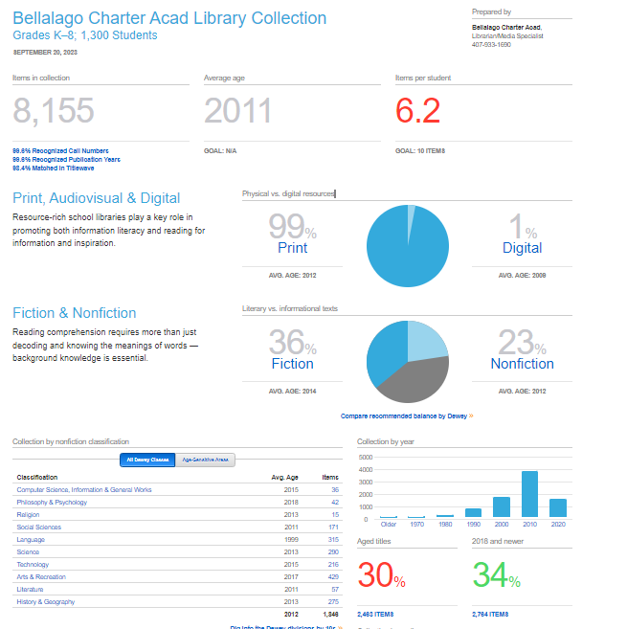
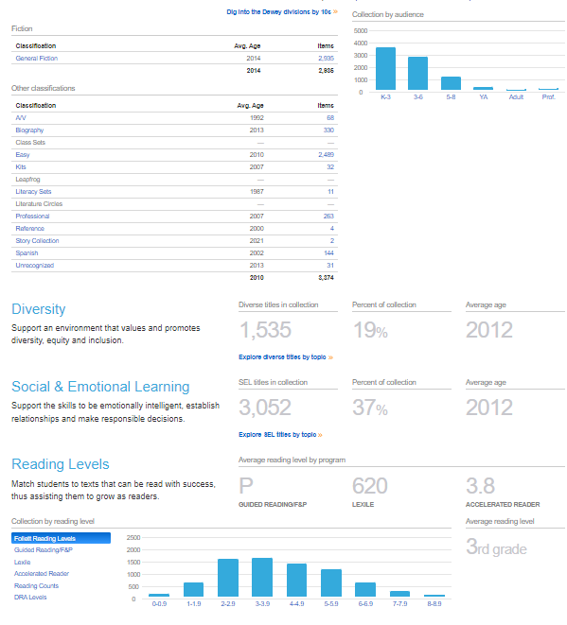

Selection Aide
Selection Aide Selection aides include, but are not limited to the following:
- School Library Journal
- Booklists
- Publisher’s Weekly Children’s Book Reviews
- Students
- ALA awards lists
- New York Times best sellers
- Bookstore best sellers
- School District of Osceola County employees (teachers, administration, district staff)
- Jobbers such as Follett, Rainbow, Permabound, etc.

Intellectual Freedom
We stand with ALA on intellectual freedom that “ALA actively advocates in defense of the rights of library users to read, seek information, and speak freely as guaranteed by the First Amendment. A publicly supported library provides free and equal access to information for all people of that community. We enjoy this basic right in our democratic society. It is a core value of the library profession.”
Weeding
An important job of the media specialist is to maintain a current and relevant collection that is appealing. Materials will continuously be evaluated using the selection criteria. Damaged, out dated, and inconsequential material will be removed from the collection.
Gifts
Bellalago Academy Media Center will accept gifts and donations. The items will be evaluated using the selection criteria. Only the items that meet the requirements will be added to the collection.
Replacements
Items will be replaced as necessary. If an item is damaged beyond repair, the patron will be asked to pay the purchase price as listed. If materials are lost, it is the media specialist’s discretion whether to charge a fine.
Special Collections
At Bellalago, the media center has a collection of resources for teachers to plan and utilize in guided reading groups. The media specialist will curate a collection of Spanish library books to support the Hispanic population.
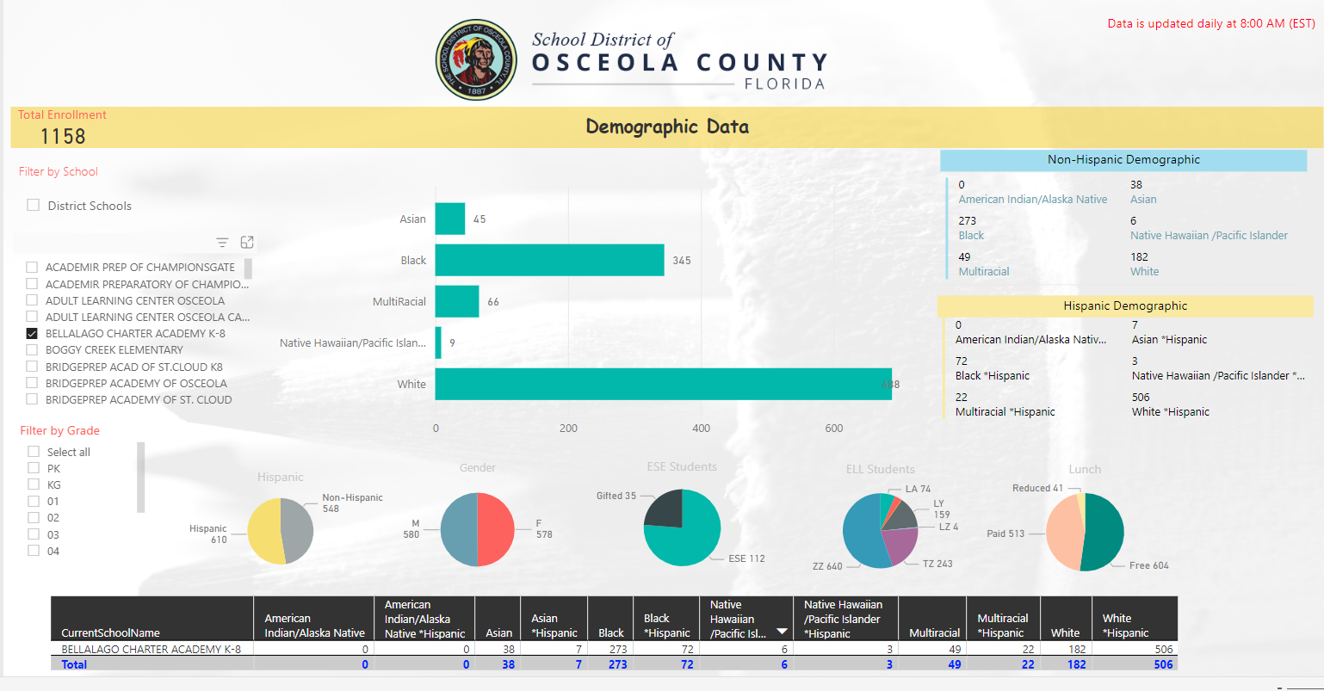

Action Plan based on collection development policy
Utilizing the Titlewave Collection Anaysis, there are areas that need to be updated and/or weeded. The technology, religion, and language areas are out of date. The age of the language collection is 1999. For these reasons, this section will be looked at first. The goal is to maintain the collection within ten years of the current year.
Challenge to instructional and library material
The final decision for Instructional and Library Materials rests with the School Board. The following procedures will be used for challenges to Instructional Library Materials. The Superintendent has designated the Director of Media and Instructional Technology to process all paperwork associated with any challenged instructional material.

- A parent or guardian of a child enrolled in the District (The “Petitioner), an employee of the District, or a resident of Osceola County may object to Instructional and Library Material by filing form FC-820-244, Request for Reconsideration of School Library Materials (the “Petition”) with the Principal.
- The Petition must be made in writing on the prescribed form, an oral complaint is not sufficient.
- The Principal will forward a copy of the petition to the Director of Media and Instructional Technology Department (MITD).
- The Director of MITD will notify the Superintendent of the challenge.
- A Petitioner who does not complete and return the form receives no further consideration.
- The challenge to any material applies only to the individual school where the challenge originated.
- During the pendency of a challenge under this procedure, the Instructional and Library Material which is the subject of the Petition will not be accessible to students.
- “Instructional and Library Material” as used in this document refers to books, other than textbooks adopted by the District or the State, utilized for classroom instruction or in the school library, digital media including but not limited to videos, DVDS, records, periodical, computer software, or other electronic media.
- The Principal will within thirty (30) days of receiving the Petition call a special meeting of the School Library Media Center Advisory Committee to address the Petition.
- The Principal or the Library Information Specialist will notify the Director of MITD on the Committee meeting.
- The Committee Chair or Library Information Specialist will request additional copies of the challenged material from MITD.
- Every committee member will receive a copy of the completed “Request for Reconsideration of School Library Material” and a copy of the material to be examined and read in its entirety.
- If there are professional reviews of the material, copies of those will be given to each committee member.
- The standards used by the Committee to determine the propriety of the Instructional and Library Material will be related to educational concerns and will include:
- The age of the children who normally could be expected to have access to the Instructional and Library Material.
- The educational purpose to be served by the material.
- The degree to which the Instructional and Library Material would be supplemented and explained by mature classroom instruction as part of a normal classroom instructional program.
- The consideration of the broad, racial, ethnic, socioeconomic, and cultural diversity of the children.
- The Committee will meet and give their decision to the Principal within the 30 days.
- The Principal or Library Information Specialist will notify the Director of MITD of the Committee meeting date and time.
- The Petitioner may be present to make a verbal and/or written statement to the Committee.
- The Committee will give its recommendation to the Principal on Form FC-820-0249.
- The Principal will notify the Petitioner of the recommendation immediately on school letterhead stationary.
- The Director of MITD will receive a copy of Form FC-820-0249 and of the Petitioner notification letter. If the school committee recommends that the book be removed, it will be sent to the Director with the accompanying paperwork.
- The Petitioner may appeal the recommendation of the school Committee to the Director of MITD in writing with ten (10) days of receipt of the school recommendation.
- The Director of MITD will organize a meeting of the District Media Review Committee (DMR) within twenty (20) days of receipt of the Petition, unless the timeline is waived by the Petitioner.
- The DMR Committee will be appointed by the Superintendent and will consist of no less than two principals, three District Level Administrators, and two persons from the community who are not employed by the District.
- The Petitioner will be notified of the time and place of the meeting.
- The Petitioner will be allowed to make a presentation at the DMR Committee meeting.
- The DMR Committee will read and examine the material in its entirety. Professional reviews and a copy of the material will be given to each committee member.
- The DMR Committee meeting is a public meeting, but no student identifying information may be made public without the parent or guardian’s consent.
- The standards used by the school Committee will apply to the DMR Committee, but will be expanded to include the concerns or issues related to all district schools.
- The DMR Committee will issue a written decision to the Director of MITD within thirty (30) days of the date of meeting.
- The decision of the DMR Committee will be mailed to the Petitioner via certified mail, return receipt requested, and will be reported to the Superintendent and School Board on the next available School Board agenda.
- The Petitioner may appeal the decision of the DMR Committee to the School Board by filing a written notice of appeal with the Director of MITD within ten (10) days of the date of receipt of the decision.
- If appealed, the School Board will make the final determination at the next available School Board meeting. The written decision of the School Board will be issued within thirty (30) days of the date of the School Board meeting.
- If the Instructional and Library Material has been challenged in accordance with this procedure and the School Board has issued a decision, the determination will be binding on all schools in the District at the same grade level as the school where the Petition originated.”(Revised 7/29/2008, Media and Instructional Technology Department)

